Why organizations issue visitor badges that expire
Expiring Visitor Badges show you instantly if visitors have signed in today. That’s because they change color overnight.
This prevents the badges from being reused.
VALID today, VOID tomorrow!
Why we need to know a badge is VALID
If the badge is WHITE, the visitor’s I.D. is VALID, meaning the badge was issued today to a visitor who has properly signed in.
Why we need to know a badge is VOID
If the badge shows “VOID,” the visitor’s badge has expired, meaning it was not issued today. In this case, the visitor should be questioned.
How do expiring badges work?
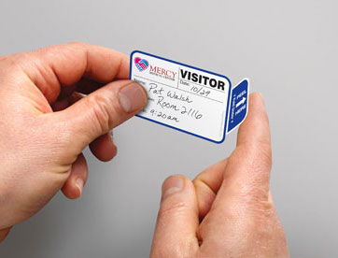
With a TAB-Expiring Visitor Badge (pictured), the front piece and the back piece come attached for easy activation.
- Expiring technology comprises two parts: a front piece and a back piece.
- These two pieces are specially engineered to work together. When these two pieces are combined, the expiring process has been activated.
- Once activated, special “migrating” ink from the back piece starts to make its way into the front piece until it’s visible. (Think of a white napkin laid on top of a drop of red wine that has spilled.)
- Gradually, the visitor’s badge changes color. By the next day, the badge is completely VOID, so it can’t be reused.
- Since the badge can’t be reused, your desk attendant does not need to retrieve it when a visitor departs.
Expiring Visitor Badges come in two formats:
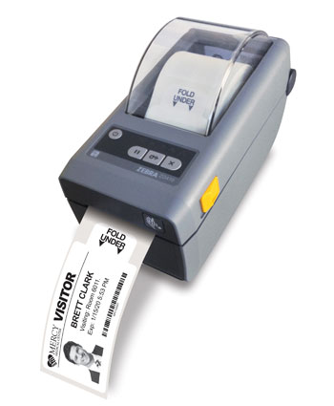
- On Rolls that are compatible with many printers and software programs.
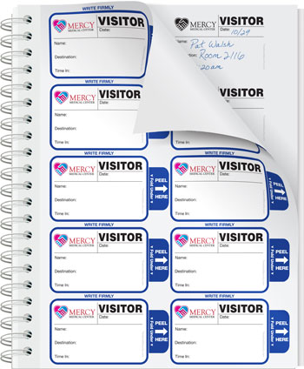
- In Visitor Badge Sign-In Books that protect everyone’s privacy.
Contact us today!

