Our expiring badges work with popular printers and visitor management software systems

The security professionals we talk to always love our unique expiring visitor badges, which change color overnight to prevent reuse.
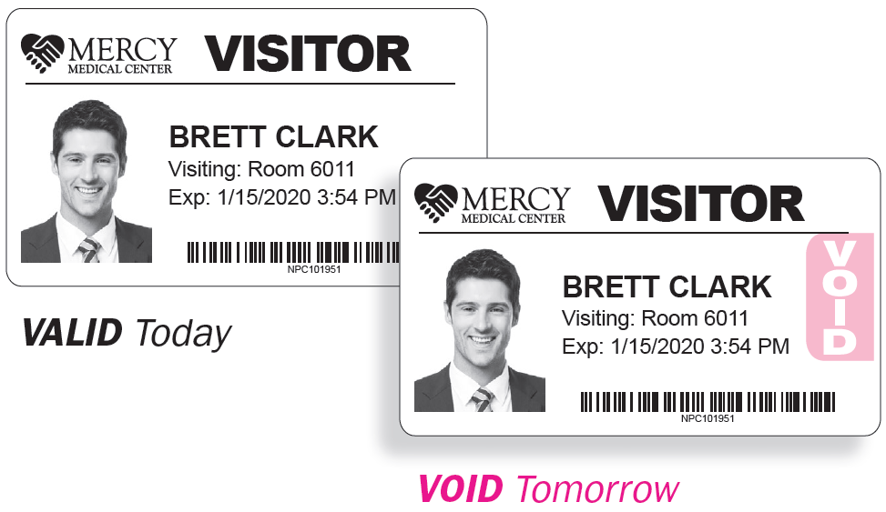
Lucky for you, our expiring badges work with the following printers and visitor management software systems.
Printers:
- DYMO
- Zebra
- Brother
- Epson
- Primera
Visitor Management Software Systems:
- Easy Lobby
- Envoy
- eVisitor
- FastPass
- HID SAFE
- iLobby
- iVisitor
- Keep N Track
- LobbyGuard
- Lobby Track
- ﻿PassagePoint
- Raptor
- Traction Guest
- Vendormate
- WhosOnLocation
Contact us today!

