Better IDs = Better Security.
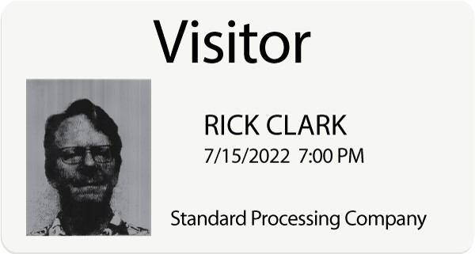
A competitor’s visitor badge
If the photos on your visitor badges look like the above, why bother taking a picture?
eVisitor software makes it easy to take visitor photos, crop them precisely, and print them beautifully (below). So your visitor badges look more like your visitors.
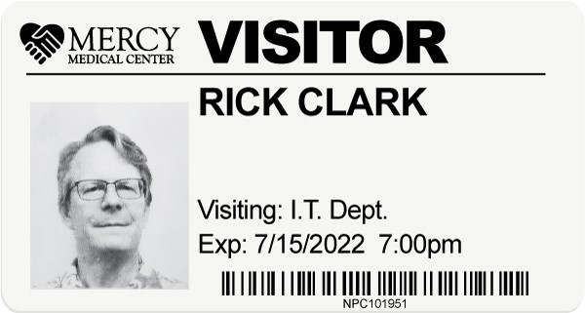
An eVisitor badge
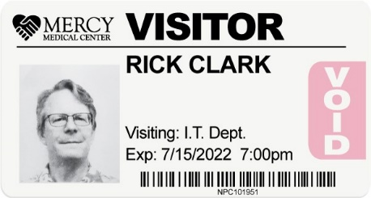
Bonus: eVisitor badges change color overnight to prevent reuse.
Contact us today!

